- As a user, I want to change my password and/or full name.

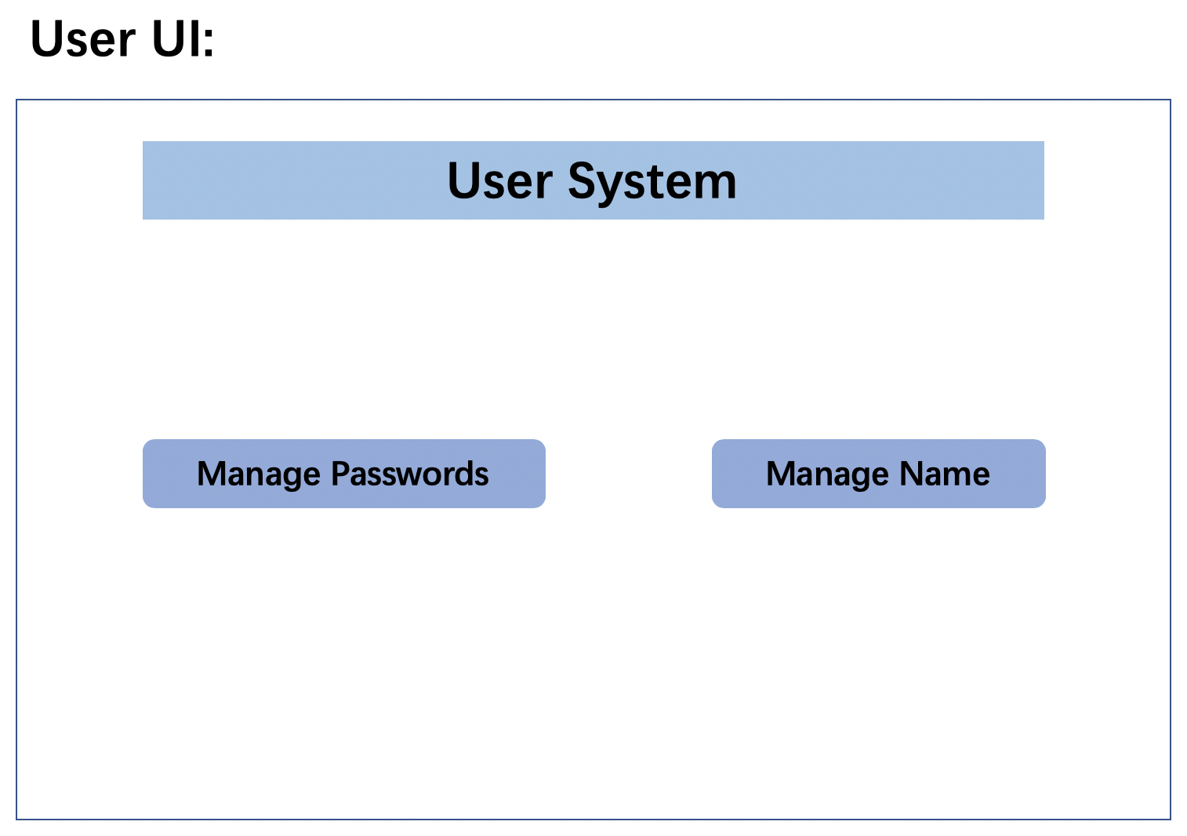

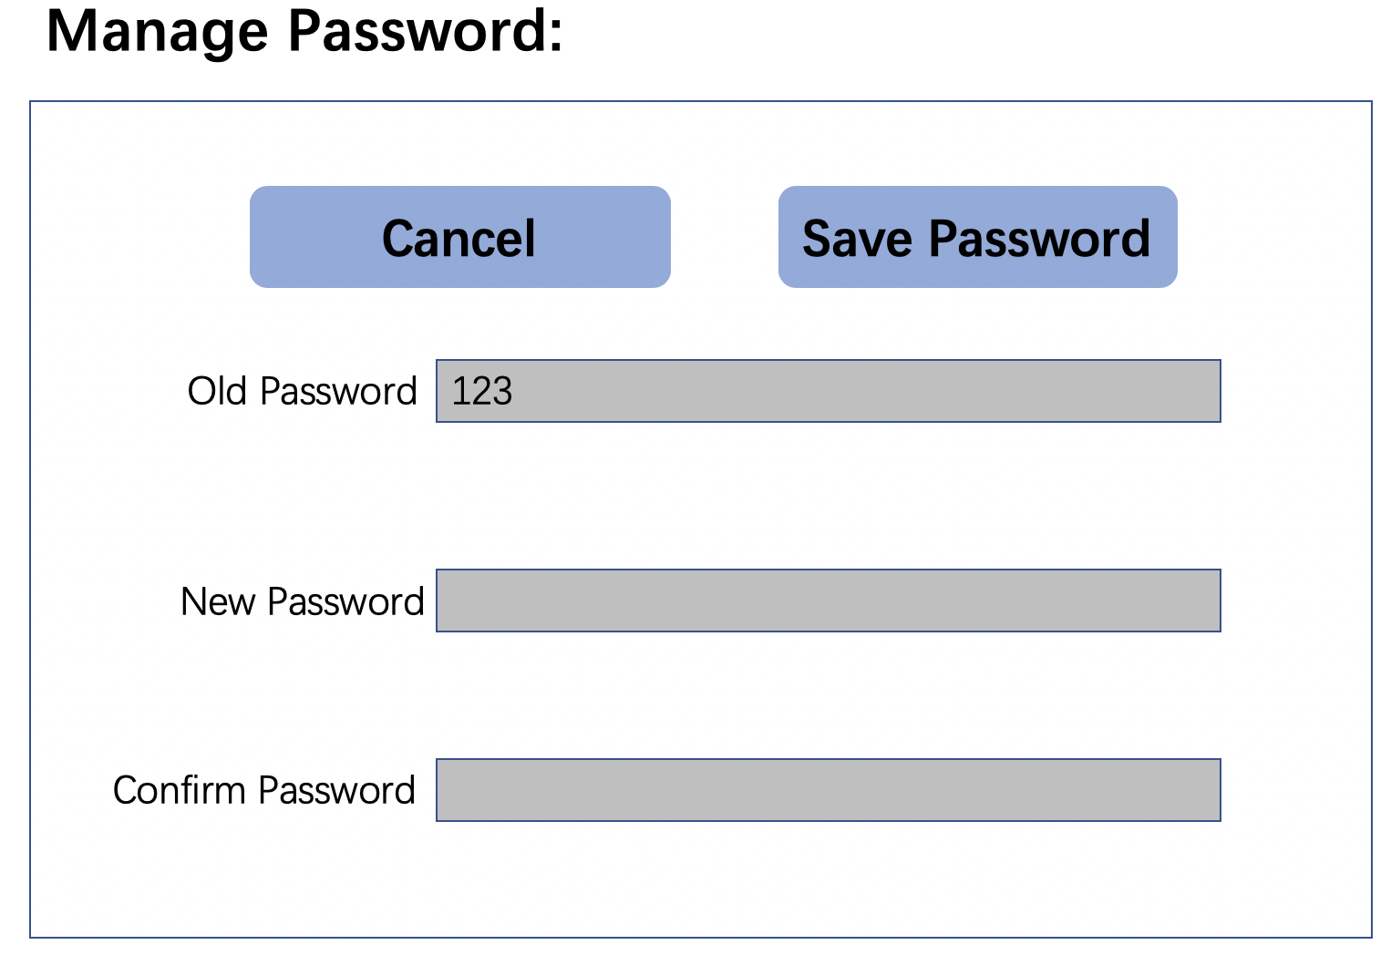

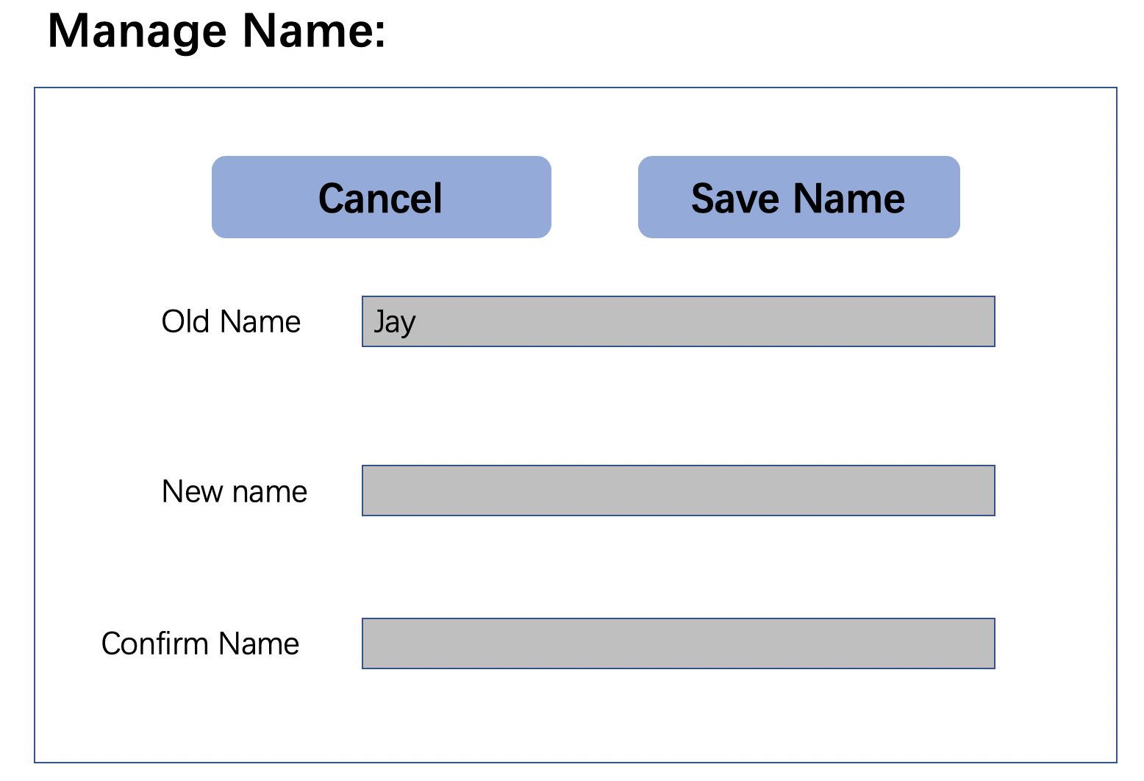

- As an admin, I want to add a new user into the system.

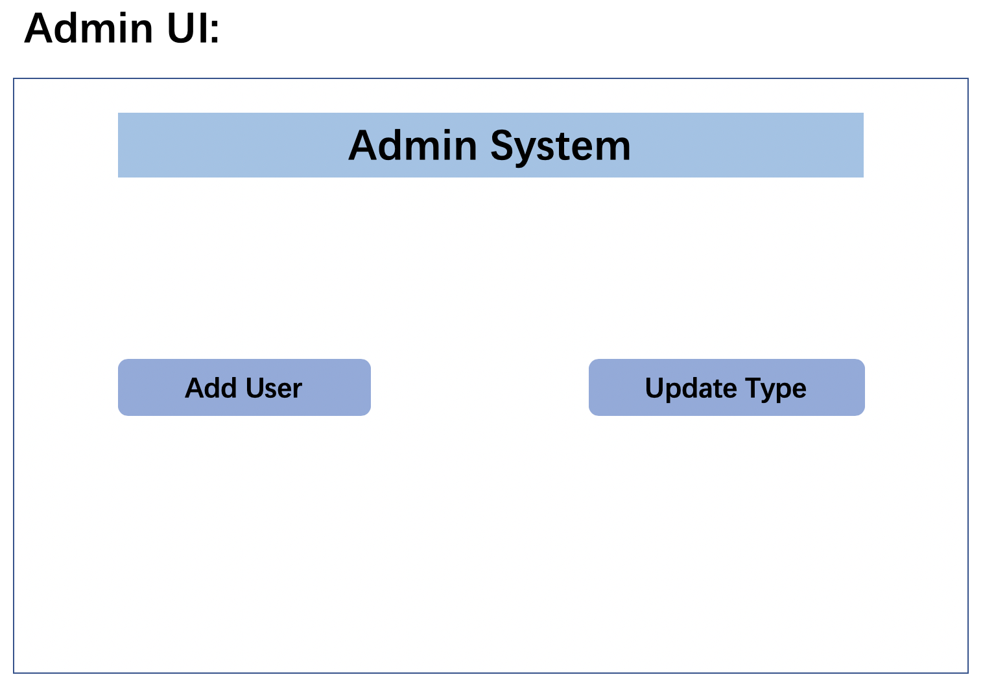

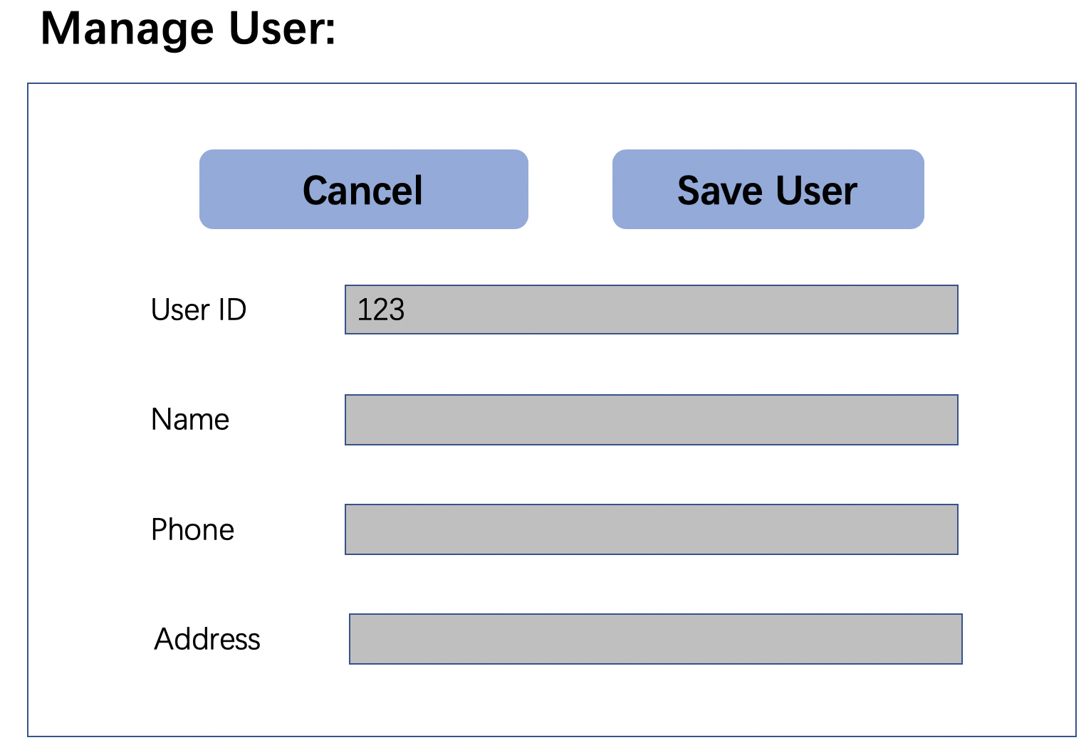

- As an admin, I want to update the type/class of a user into the system (e.g., from cashier to manager).



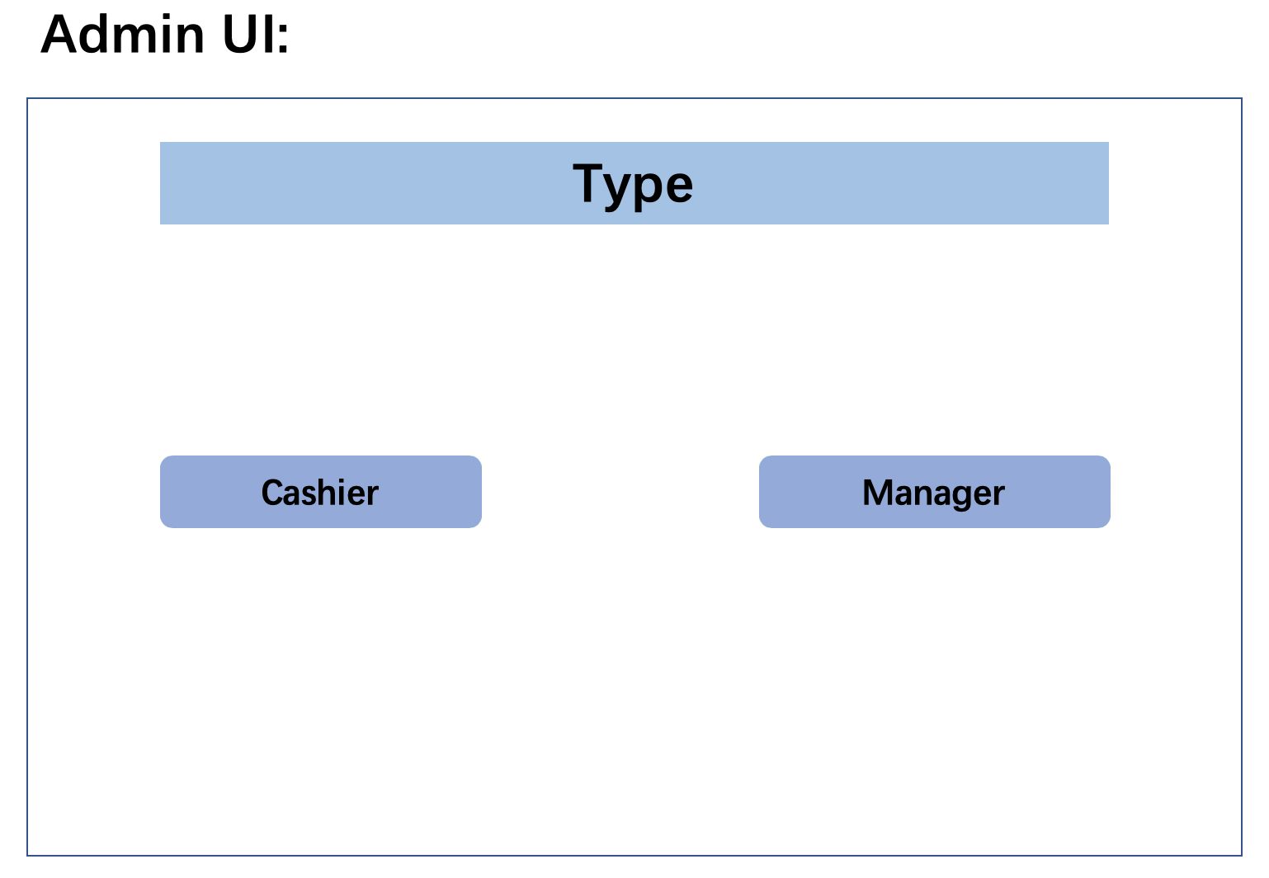

- As a manager, I want to add a new product or update a current product in the system.

1. Click “Manage Products” in Main Screen:

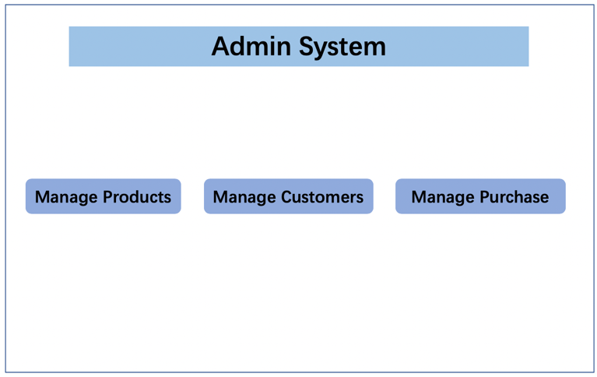

2. Display “Manage Products” screen:



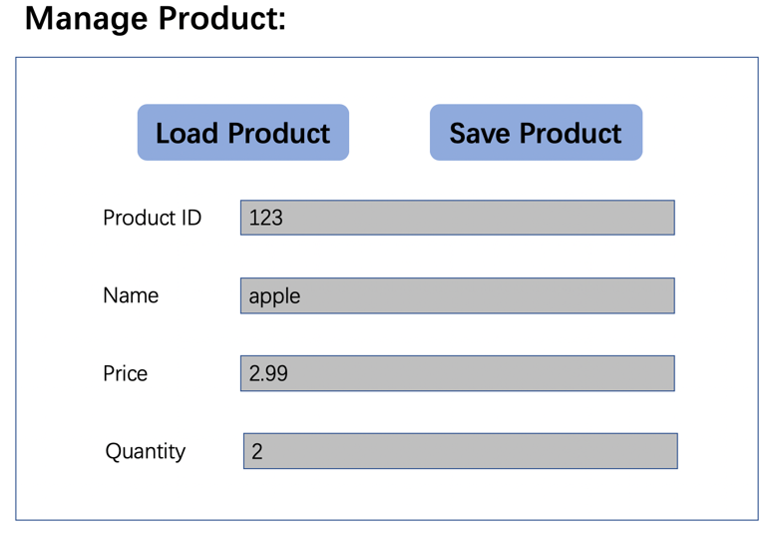

3. Display “Product is SAVED successfully!” screen when saved product.

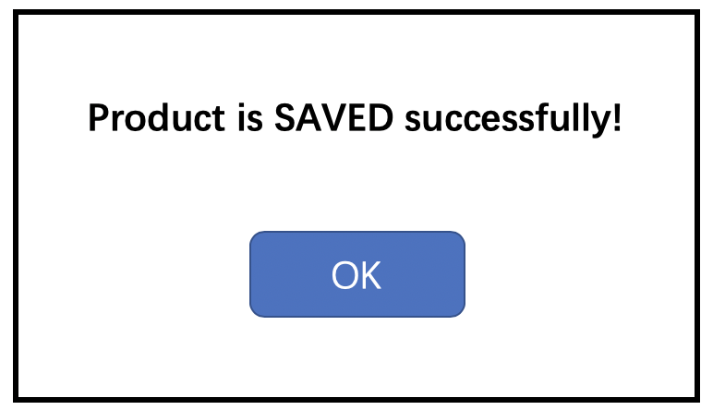

Case 2: Update a current product

1. Click “Manage Products” in Main Screen:

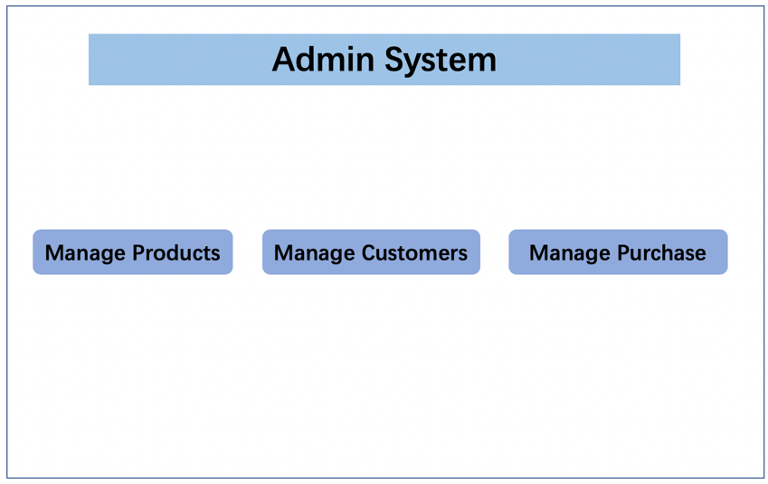

2. Display “Manage Products” screen:



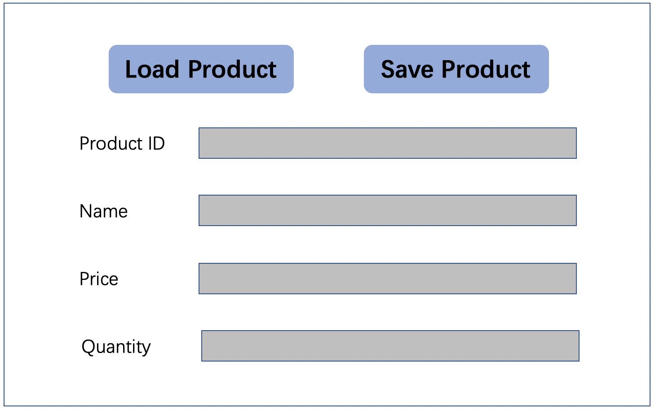

3. Input the Product ID

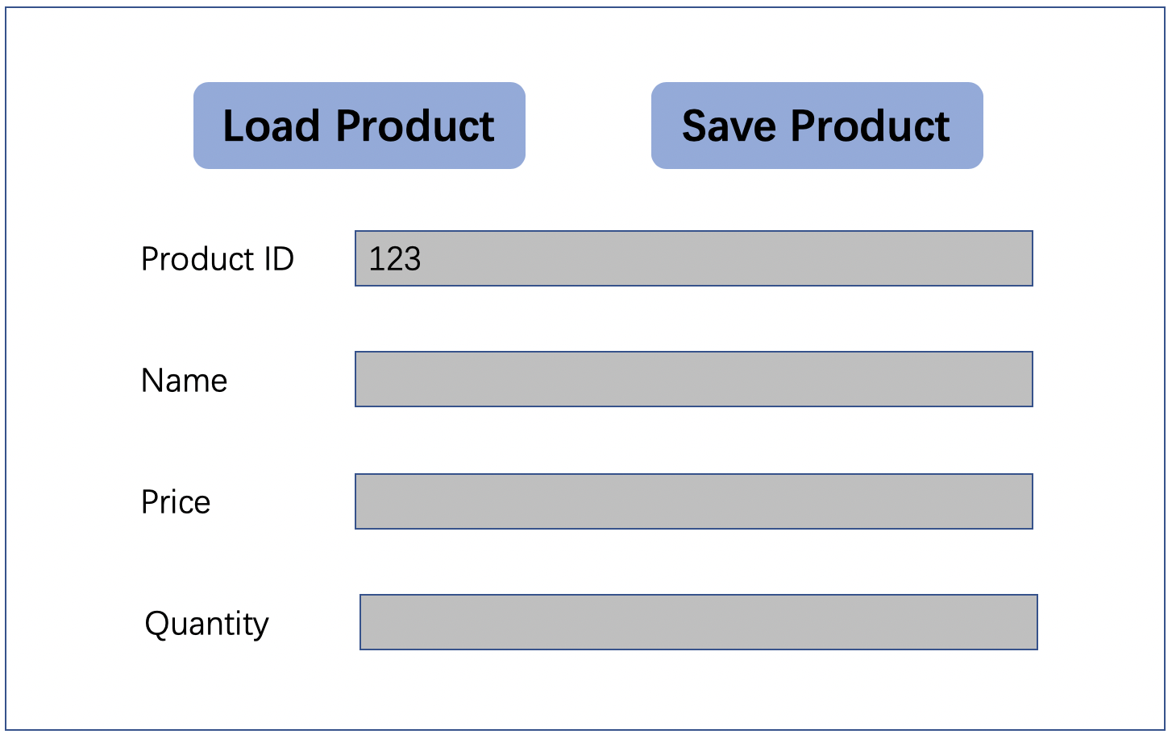

4. Display “Load Product” screen with ProductID:

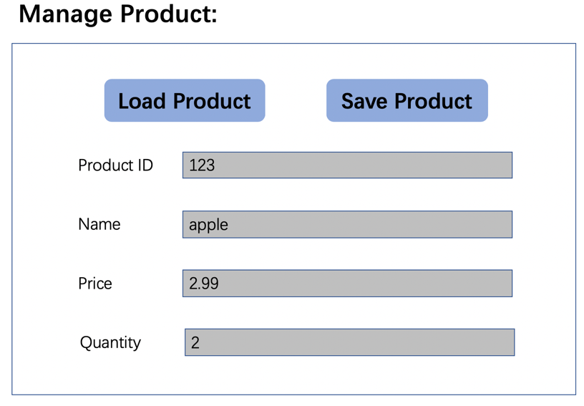

5. Click “Save Product” button after changing data to get “Product is SAVED successfully!” screen



- As a manager, I want to view a summary report of sales from the system.



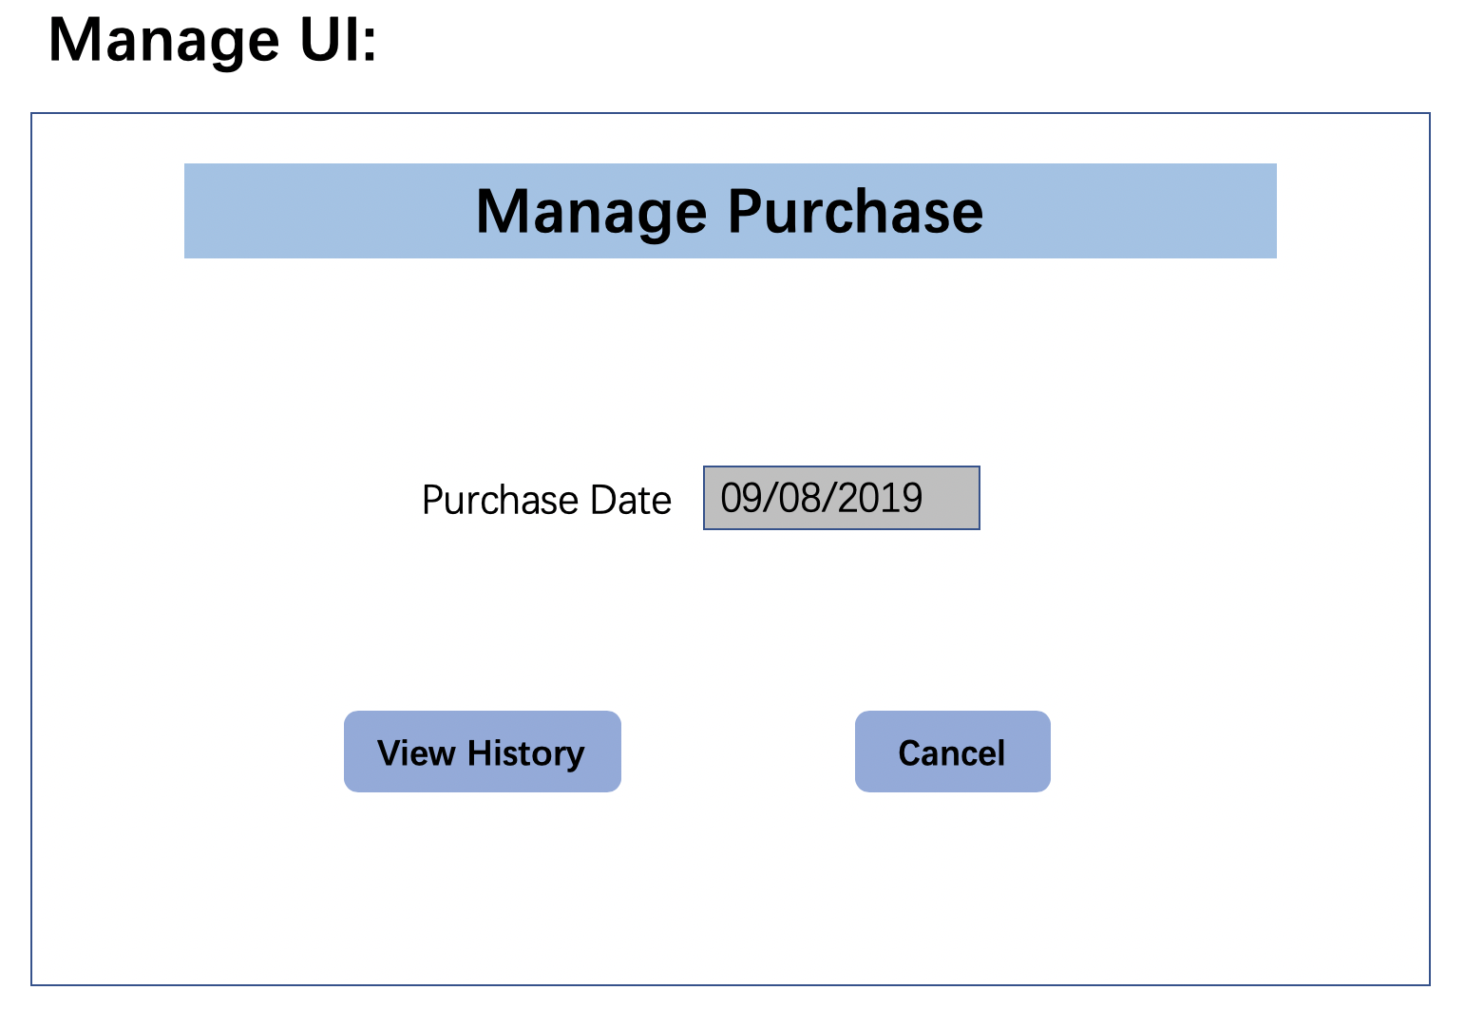

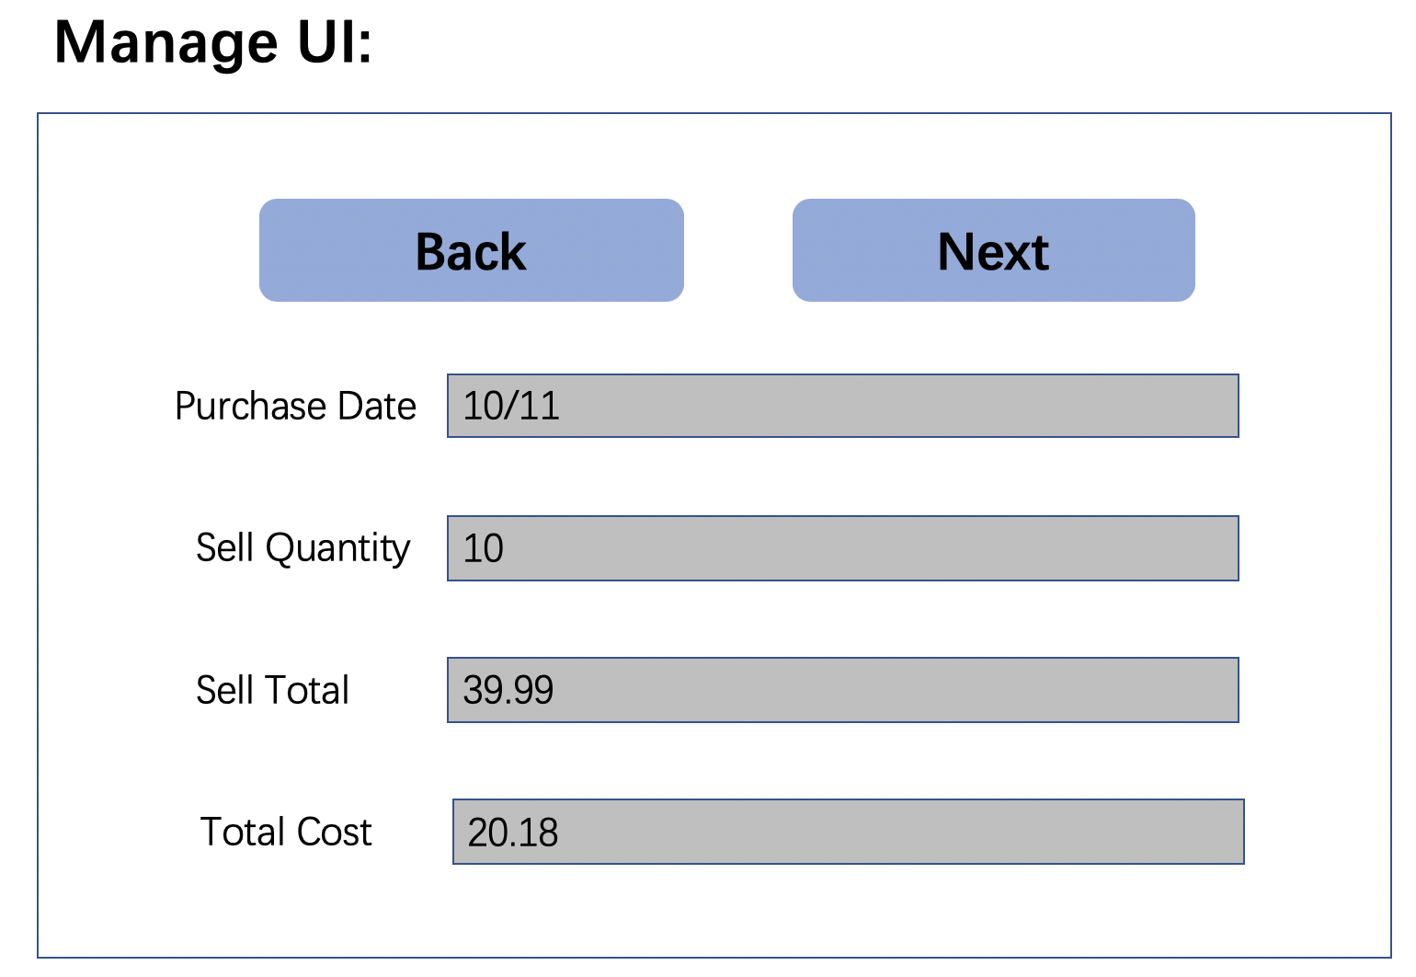

- As a cashier, I want to add a new customer or update a current customer in the system.

Case 1: Add a new customer

1. Click “Manage Customers” in Main Screen:

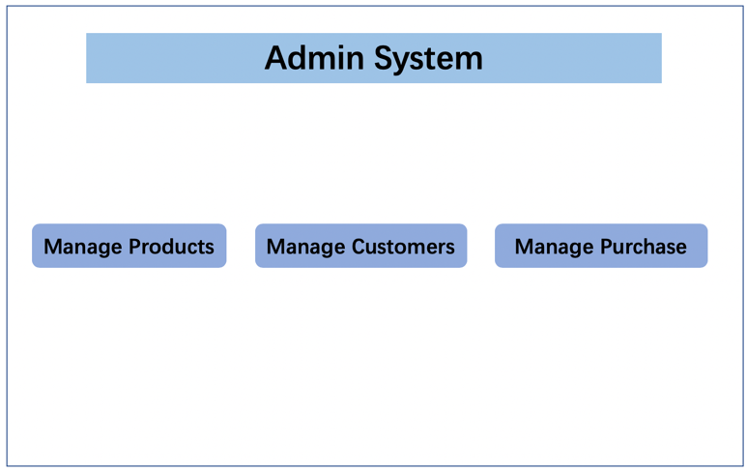

2. Display “Manage Customers” screen:

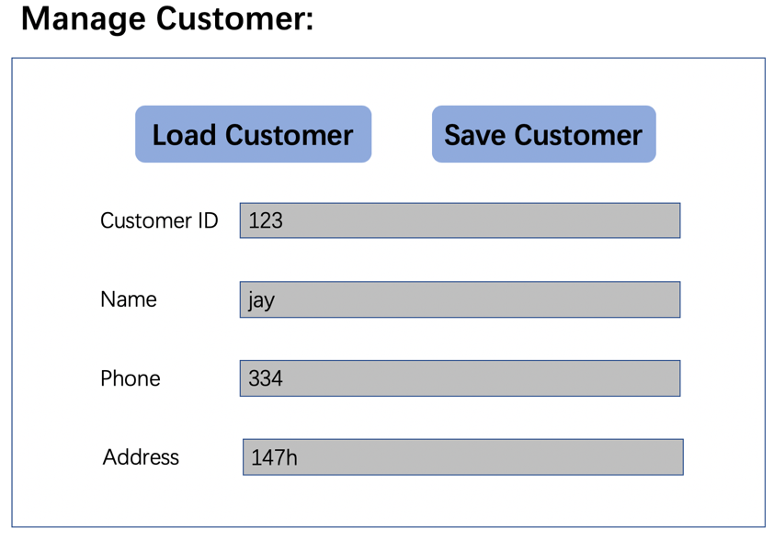

3. Display “Customer is SAVED successfully!” screen when saved customer.

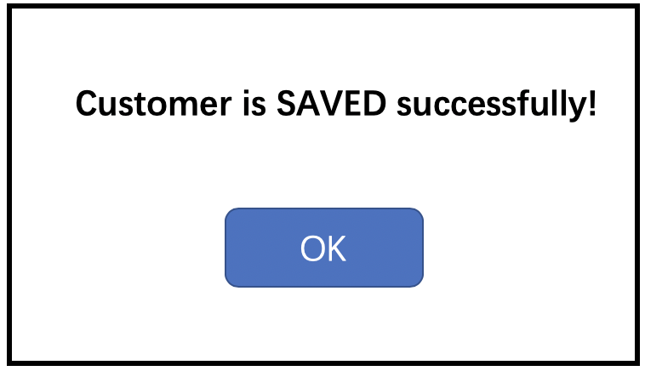

Case 2: Update a current customer

1. Click “Manage Customers” in Main Screen:



2. Display “Manage Customers” screen:

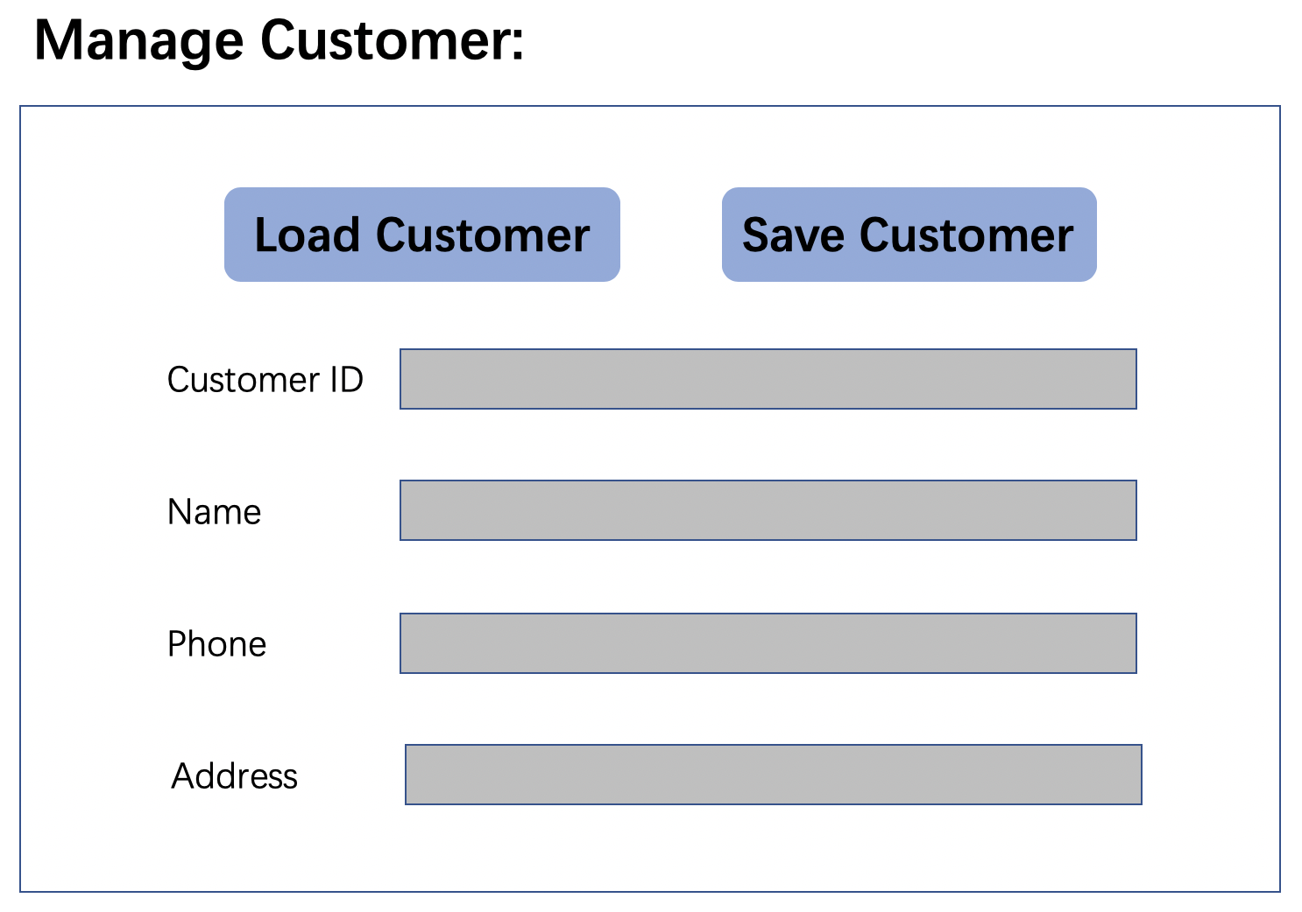

3. Input the Customer ID

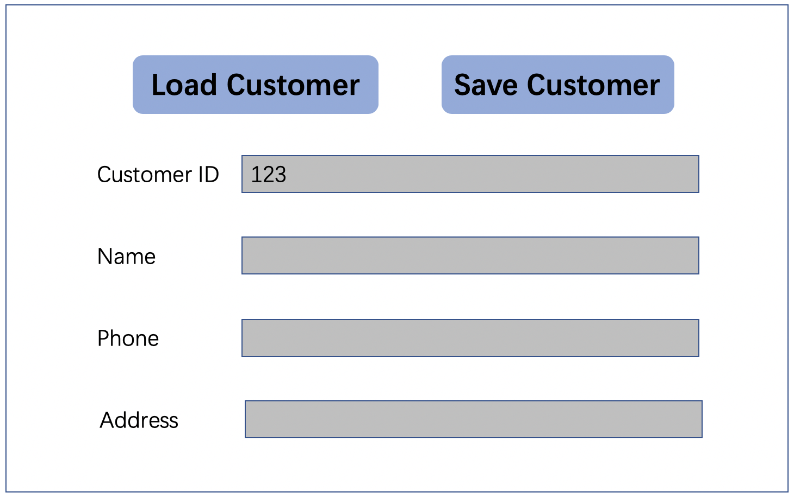

4.Display “Load Customer” screen with CustomerID:

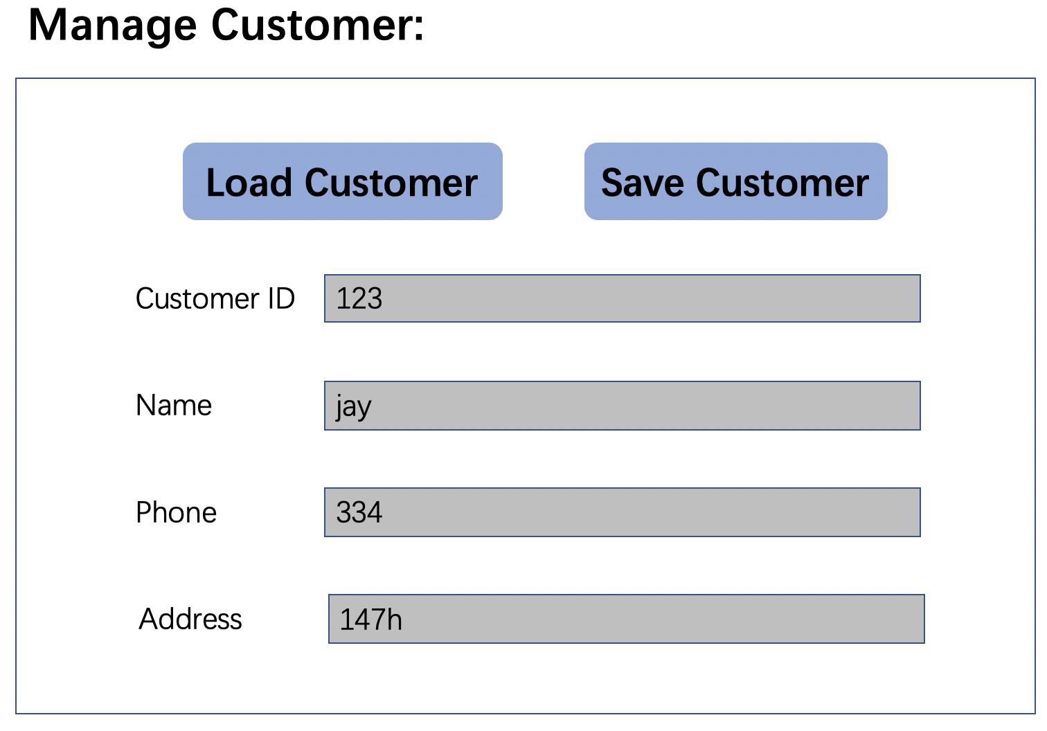

5. Click “Save Customer” button after changing data to get “Customer is SAVED successfully!” screen



- As a cashier, I want to add a new purchase or update a current purchase (only price and quantity) in the system.

Case 1: Add a new purchase

1. Click “Manage Purchase” in Main Screen:



2. Display “Manage Purchase” screen:

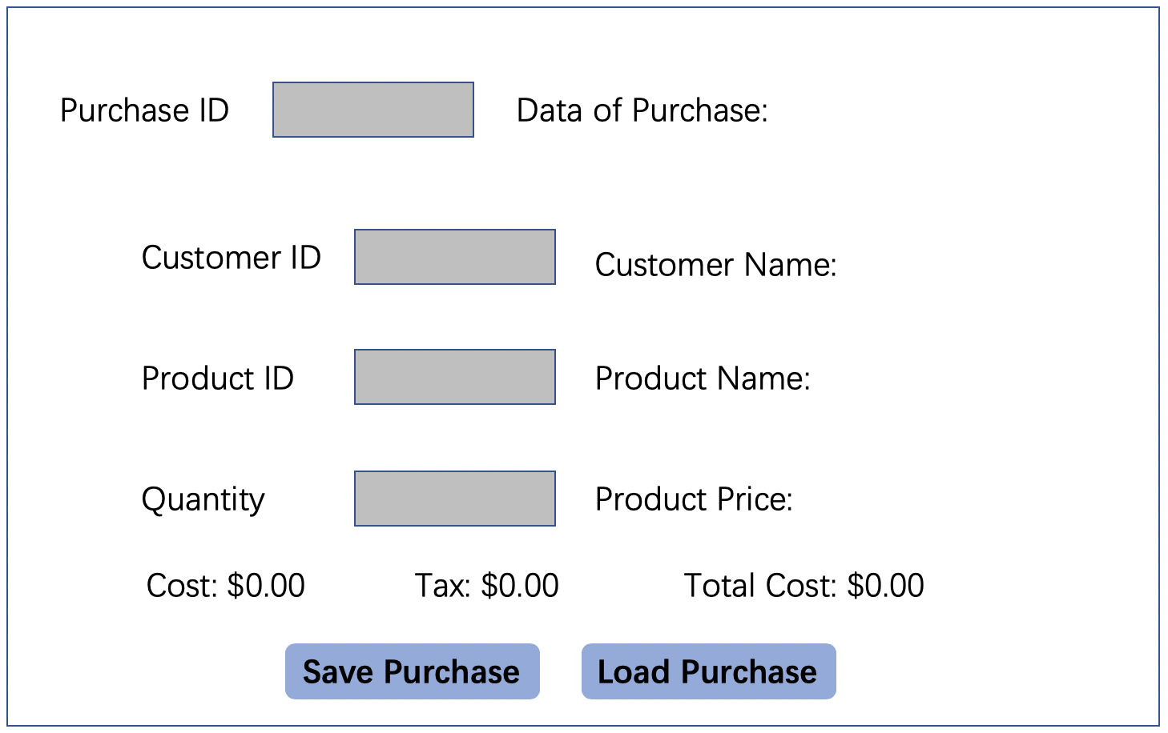

3. Input data then save purchase by Clicking “Save Purchase”

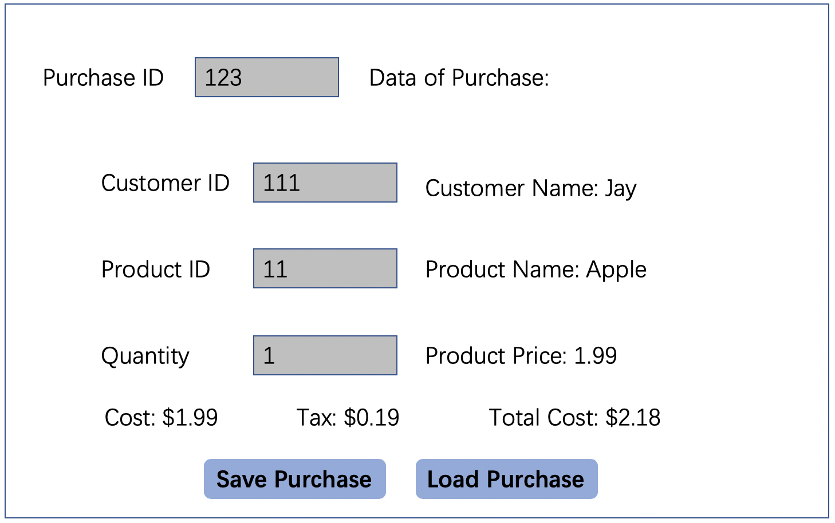

4. Display “Purchase is SAVED successfully!” screen

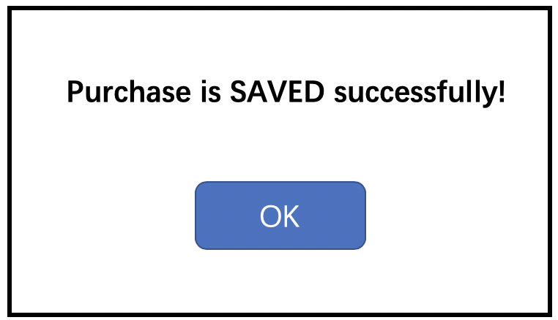

Case 2: Update a current purchase

1. Click “Manage Purchases” in Main Screen:



2. Display “Manage Purchases” screen:



3. Input the Purchase ID:

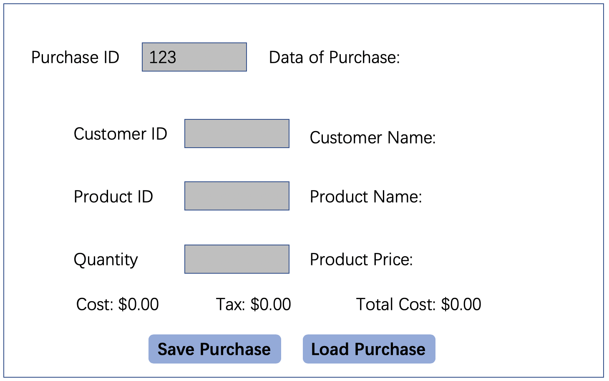

4. Display “Load Purchases” screen with data:



5. Click “Save Purchase” button after changing data to get “Purchase is SAVED successfully!” screen



- As a customer, I want to add a new purchase into the system.

1. Click “Manage Purchase” in Main Screen:



2. Display “Manage Purchase” screen:



3. Input data then save purchase by Clicking “Save Purchase”



4. Display “Purchase is SAVED successfully!” screen

- As a customer, I want to view my purchase history into the system.

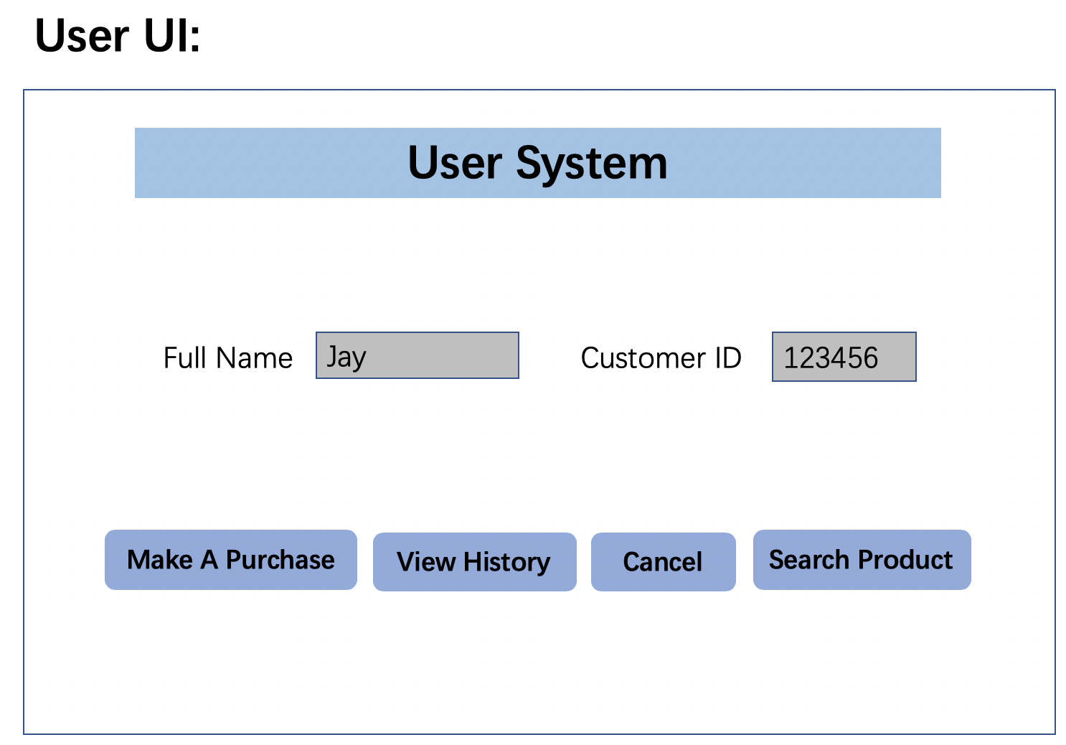

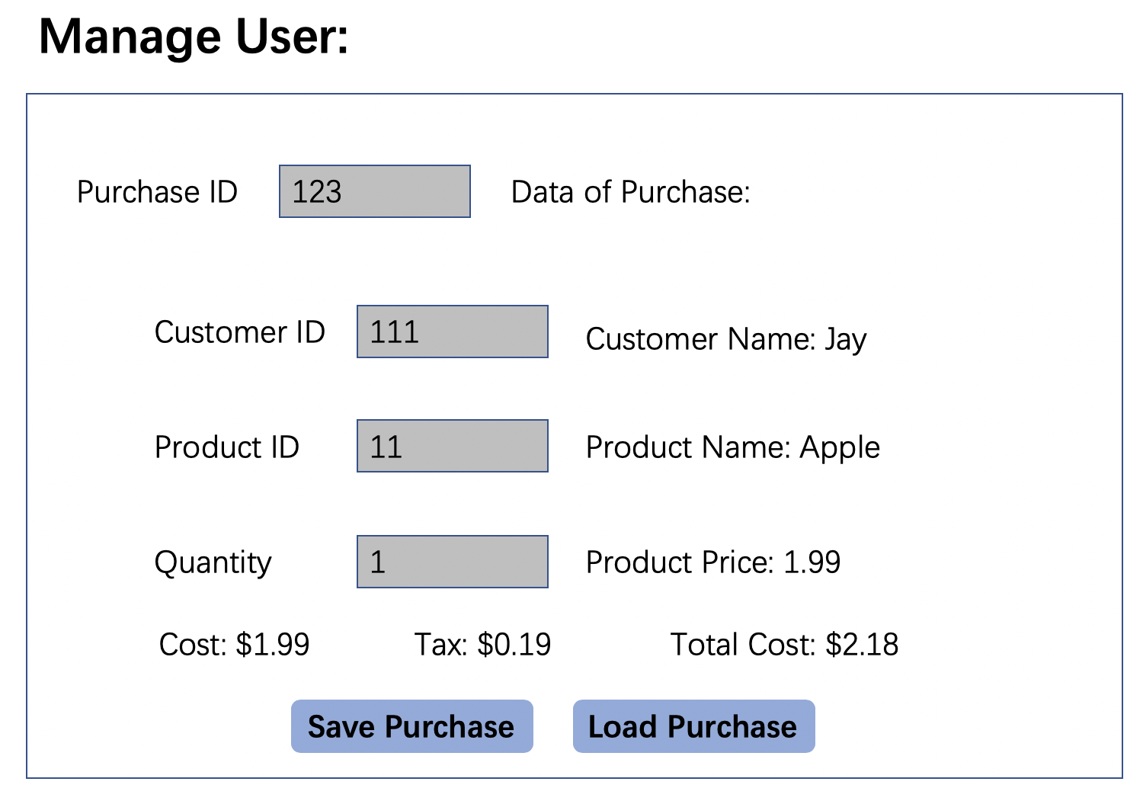

- As a customer, I want to search for product information (based on name, price) in the system.



